**Coffee Shop**

**Architecture:**

On the front-end, React.js is used to create the user interface, leveraging its component-based architecture to build reusable UI elements. Node.js may also serve the React.js application, enabling a full-stack JavaScript development approach.

By combining these technologies, developers can create robust, scalable, and feature-rich applications that leverage the power of version control, cloud-based services, NoSQL databases, and modern user interface development.

WorkFlow:

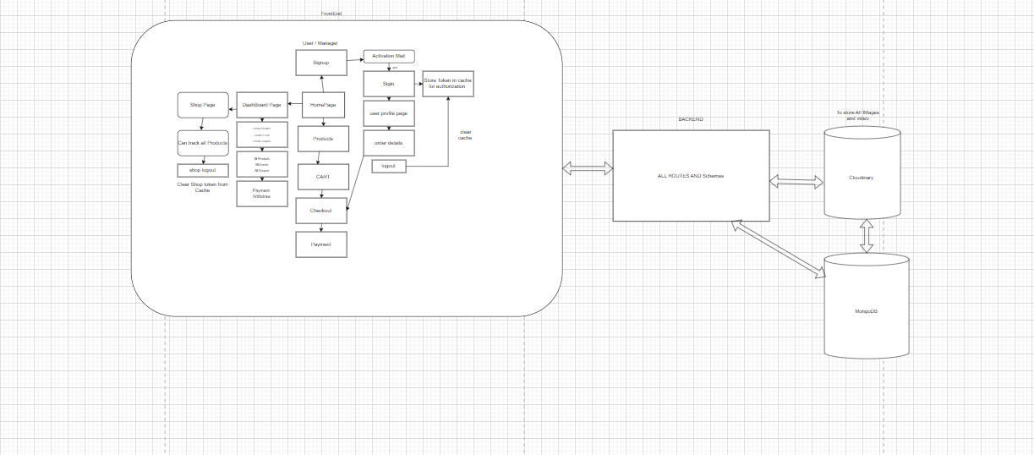

**Github and how multiple developer worked same project**

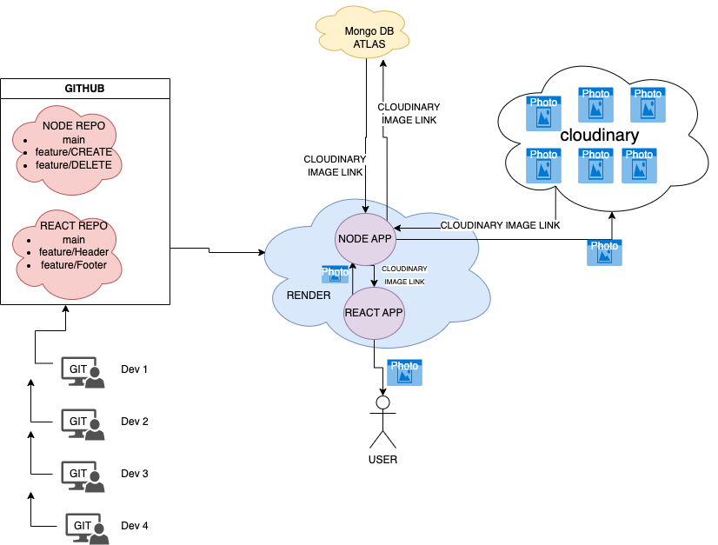

**BACKEND :  
  
Dependendies:**

* **bcrypt and bcryptjs**:- These packages are used for password hashing and encryption.
* **cloudinary**:- This package provides integration with the Cloudinary service for image and video management.
* **cookie-parser**: - This package is used for parsing and handling HTTP cookies.
* **cors**:- CORS (Cross-Origin Resource Sharing) package allows you to handle cross-origin requests in your backend.
* **dotenv**:- This package is used for loading environment variables from a .env file.
* **express**:- Express is a popular web application framework for Node.js.
* **js-cookie**:- This package provides a simple API for handling cookies in the browser.
* **jsonwebtoken**:- This package is used for generating and verifying JSON Web Tokens (JWT) for authentication and authorization purposes.
* **mongoose**: "^7.0.0" - Mongoose is an Object Data Modeling (ODM) library for MongoDB and provides a straightforward way to interact with MongoDB databases.
* **nodemailer**:- Nodemailer is a module for Node.js applications that allows sending emails.
* **nodemon**:- Nodemon is a utility that automatically restarts your Node.js application when file changes are detected. It is commonly used in development environments.
* **stripe** - Stripe is a popular payment processing platform, and this package allows integration with Stripe's API for handling payments.

**MongoDb:**

MongoDB is a NoSQL database that offers a flexible, scalable, and document-oriented approach to data storage and retrieval. It is designed to handle large volumes of unstructured or semi-structured data, making it ideal for modern web applications, mobile apps, and big data projects. MongoDB's key features include support for JSON-like documents, dynamic schemas, automatic sharding for horizontal scaling, and high availability through replica sets. Its ease of use and ability to handle complex data structures make it a popular choice for projects requiring agile development and real-time data access.

**ER Schema:**

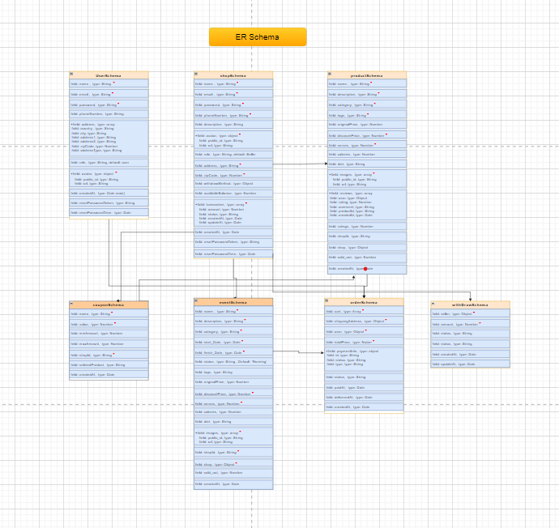

**Controllers:  
1.User Routes:**

* **/api/v2/user/create-user**: POST request to create a new user.
* **/api/v2/user/activation**: POST request to activate a user account.
* **/api/v2/user/login-user**: POST request to log in a user.
* **/api/v2/user/getuser**: GET request to retrieve user information.
* **/api/v2/user/logout**: GET request to log out a user.
* **/api/v2/user/update-user-info**: PUT request to update user information.
* **/api/v2/user/update-avatar**: PUT request to update user avatar.
* **/api/v2/user/update-user-addresses**: PUT request to update user addresses.
* **/api/v2/user/delete-user-address/:id**: DELETE request to delete a user address by ID.
* **/api/v2/user/update-user-password**: PUT request to update user password.
* **/api/v2/user/user-info/:id**: GET request to retrieve specific user information by ID.

**2.Shop Routes:**

* **/api/v2/shop/create-shop**: POST request to create a new shop.
* **/api/v2/shop/activation**: POST request to activate a shop account.
* **/api/v2/shop/login-shop**: POST request to log in a shop.
* **/api/v2/shop/getSeller**: GET request to retrieve seller information.
* **/api/v2/shop/logout**: GET request to log out a shop.
* **/api/v2/shop/get-shop-info/:id**: GET request to retrieve specific shop information by ID.
* **/api/v2/shop/update-shop-avatar**: PUT request to update shop avatar.
* **/api/v2/shop/update-seller-info**: PUT request to update seller information.
* **/api/v2/shop/admin-all-sellers**: GET request to retrieve information for all shops (admin functionality).
* **/api/v2/shop/update-payment-methods**: DELETE request to update shop's payment methods.
* **/api/v2/shop/delete-withdraw-method**: DELETE request to delete a shop's withdraw method.

**3.Product Routes:**

* **/api/v2/product/create-product**: POST request to create a new product.
* **/api/v2/product/get-all-products-shop/:id**: GET request to retrieve all products of a specific shop using its ID.
* **/api/v2/product/delete-shop-product/:id**: DELETE request to delete a product from a shop using its ID.
* **/api/v2/product/get-all-products**: GET request to retrieve all products from all shops.
* **/api/v2/product/create-new-review**: PUT request to create a new review for a product.
* **/api/v2/product/admin-all-products**: GET request to retrieve all products.

**4.Event Routes:**

* **/api/v2/event/create-event**: POST request to create a new event.
* **/api/v2/event/get-all-events**: GET request to retrieve all events.
* **/api/v2/event/get-all-events/:id**: GET request to retrieve all events of a specific shop using its ID.
* **/api/v2/event/delete-shop-event/:id**: DELETE request to delete an event from a shop using its ID.
* **/api/v2/event/admin-all-events**: GET request to retrieve all events (admin functionality).

**5. Order Routes:**

* **/api/v2/order/create-order**: POST request to create a new order.
* **/api/v2/order/get-all-orders/:userId**: GET request to retrieve all orders for a specific user using their ID.
* **/api/v2/order/get-seller-all-orders/:shopId**: GET request to retrieve all orders for a specific shop (seller) using its ID.
* **/api/v2/order/update-order-status/:id**: PUT request to update the status of an order using its ID.
* **/api/v2/order/order-refund/:id**: PUT request to initiate a refund for an order using its ID.
* **/api/v2/order/order-refund-success/:id**: PUT request to mark a refund as successful for an order using its ID.
* **/api/v2/order/admin-all-orders**: GET request to retrieve all orders

**6.Payment Routes:**

* **/api/v2/payment/process**: POST request to process a payment.
* **/api/v2/payment/stripeapikey**: GET request to retrieve the Stripe API key

**7. Coupon Routes:**

* **/api/v2/coupon/create-coupon-code**: POST request to create a new coupon code.
* **/api/v2/coupon/get-coupon/:id**: GET request to retrieve a coupon by its ID.
* **/api/v2/coupon/delete-coupon/:id**: DELETE request to delete a coupon by its ID.
* **/api/v2/coupon/get-coupon-value/:name**: GET request to retrieve a coupon by its name.

**8.Withdraw Routes:**

* **/api/v2/withdraw/create-withdraw-request**: POST request to create a new withdraw request.
* **/api/v2/withdraw/get-all-withdraw-request**: GET request to retrieve all withdraw requests.
* **/api/v2/withdraw/update-withdraw-request/:id**: PUT request to update a withdraw request by its ID.

**FRONTEND:   
  
Dependencies:  
  
React and ReactDOM (react, react-dom, react-scripts):**

* React is a popular JavaScript library for building user interfaces, and ReactDOM is the entry point for React to interact with the DOM. react-scripts provides a set of scripts and configurations for running the development server and building the React application.
* **Material-UI (@material-ui/core, @material-ui/data-grid):**

Material-UI is a popular UI component library based on Google's Material Design guidelines. It provides a collection of ready-to-use components for creating modern and visually appealing user interfaces.

* **React PayPal Integration (@paypal/react-paypal-js):**

This package provides a React integration for PayPal services, allowing developers to easily integrate PayPal payments into their applications.

* **Stripe Integration (@stripe/react-stripe-js, @stripe/stripe-js):**

These packages provide a React integration for Stripe, a popular payment gateway platform. They enable developers to accept secure payments and manage customer information in their React applications.

* **React Router (react-router-dom):**

React Router is a routing library that allows developers to handle client-side navigation in a single-page application. It enables navigation and rendering of different components based on the URL.

* **Redux and Redux Toolkit (redux, react-redux, @reduxjs/toolkit, redux-thunk, redux-toolkit):**

Redux is a state management library that helps manage the application's global state in a predictable and scalable way. react-redux provides React bindings for Redux, making it easier to connect React components to the Redux store. @reduxjs/toolkit and redux-toolkit are utility libraries for simplifying Redux setup and reducing boilerplate code. redux-thunk is a middleware for handling asynchronous actions in Redux.

* **Axios (axios):**

Axios is a popular JavaScript library for making HTTP requests, which simplifies handling asynchronous data fetching from APIs.

* **React Icons (react-icons):**

React Icons is a library that provides a set of icons as React components, allowing developers to easily use icons in their React applications.

* **React Lottie (react-lottie):**

React Lottie is a library that allows developers to use Lottie animations (JSON-based animations) in their React applications.

* **React Toastify (react-toastify):**

React Toastify is a library for displaying toast notifications in React applications, providing a user-friendly way to show messages or alerts.

* **Country-State-City (country-state-city):**

This package provides data related to countries, states, and cities, making it useful for applications dealing with location-based information,

* **Tailwind CSS:**

Tailwind CSS is a utility-first CSS framework that provides a set of pre-defined CSS classes representing common styles and design patterns. Rather than using pre-designed components, Tailwind CSS focuses on providing low-level utility classes that can be combined to create custom designs quickly and efficiently.

React application utilizing Material-UI for its user interface components, integrating with payment services like PayPal and Stripe, managing state using Redux and Redux Toolkit, and using various other libraries for testing, data fetching, and notifications. It seems to be a well-rounded setup for building a modern web application with robust features and performance tracking capabilities. Tailwind CSS is a utility-first CSS framework

**App.js** file is the main entry point for a React web application. The application a multi-page web application with user authentication, seller functionalities, and an admin dashboard. It utilizes various React libraries, routing, and state management to create a comprehensive user experience.

**Pages:  
1. HomePage: \  
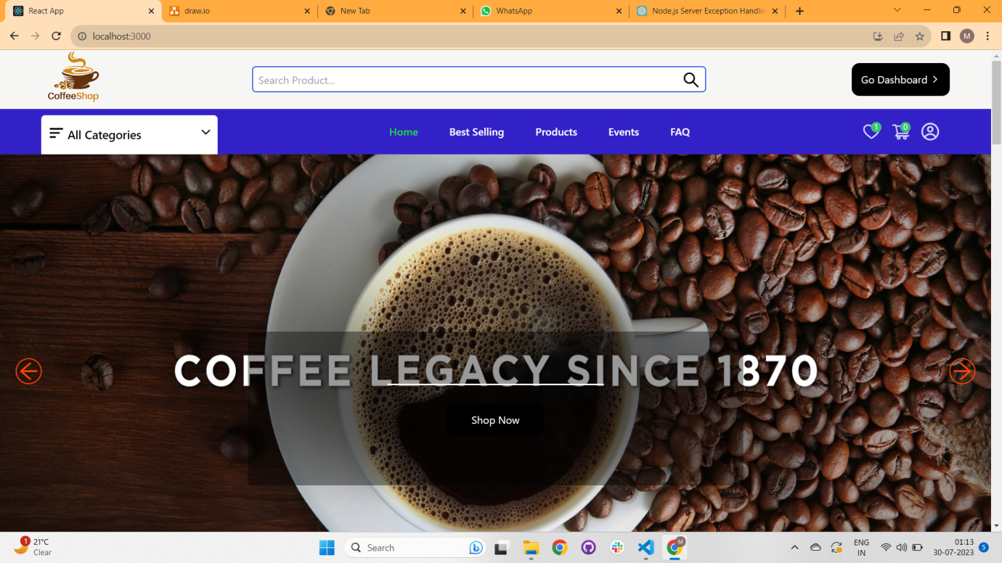**

**Categories:**

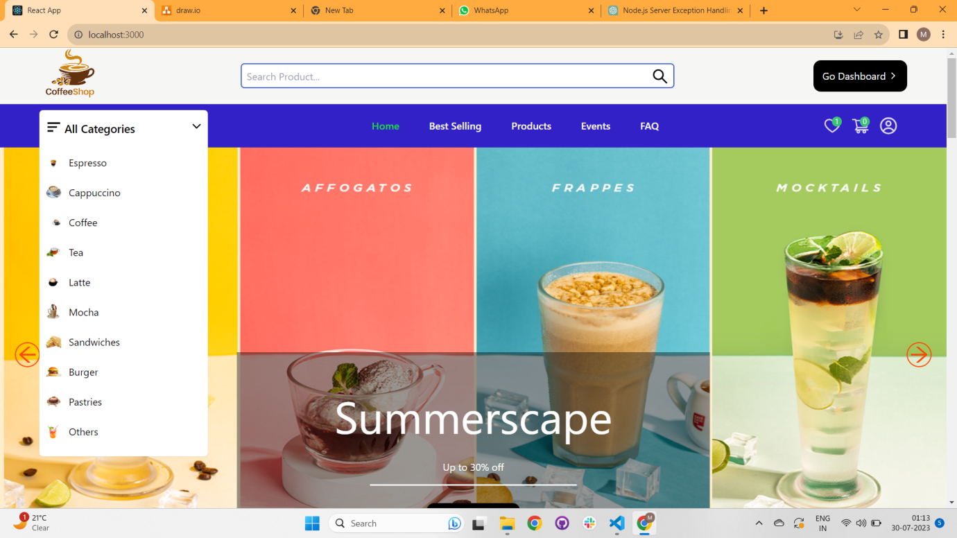

**Wishlist:**

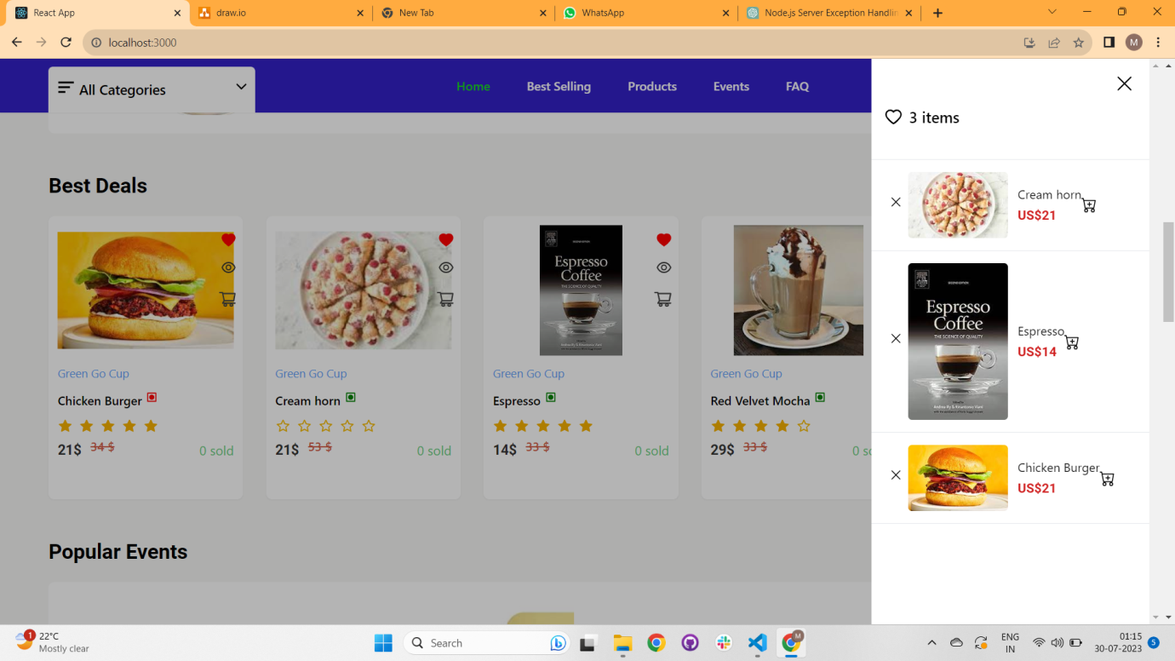

**Cart:**

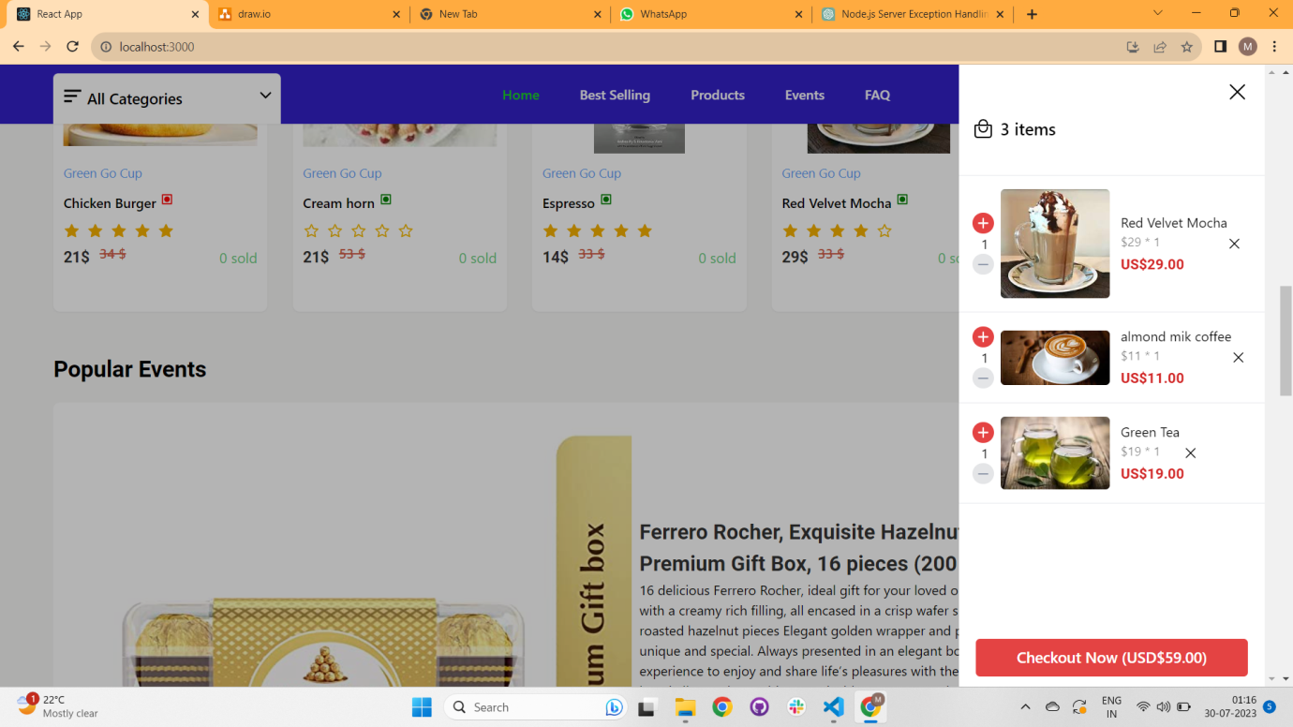

**2. Best Selling Page : /best-selling**

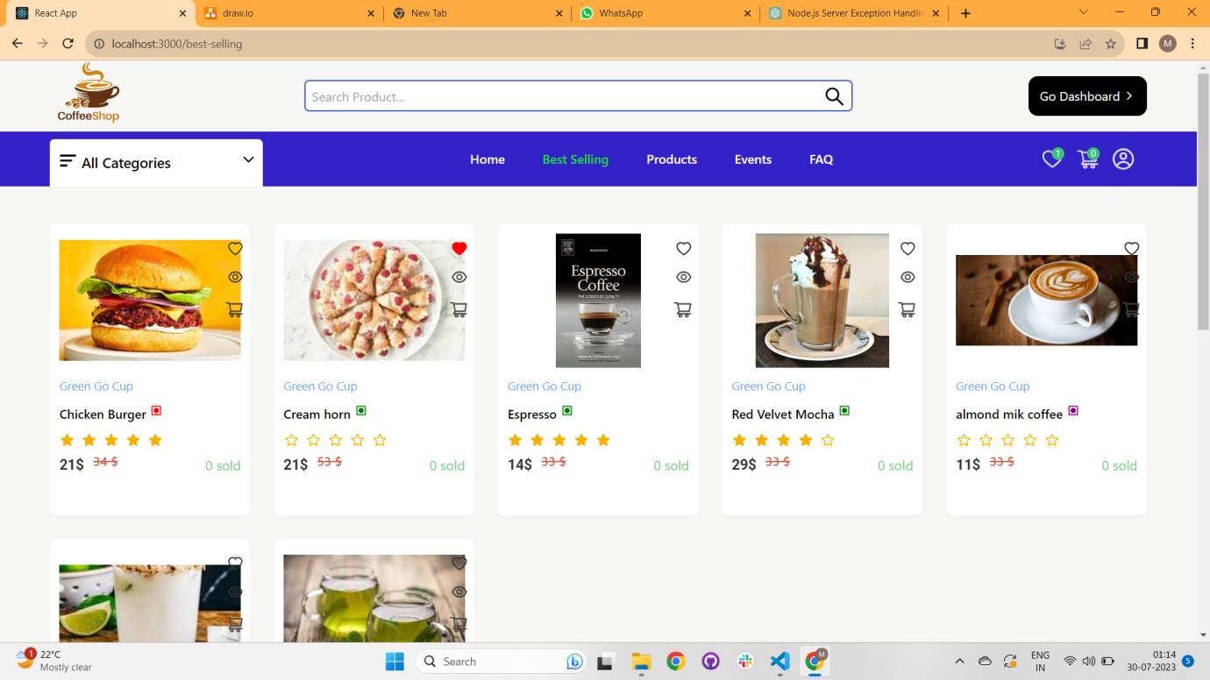

**3.Product Page : /products**

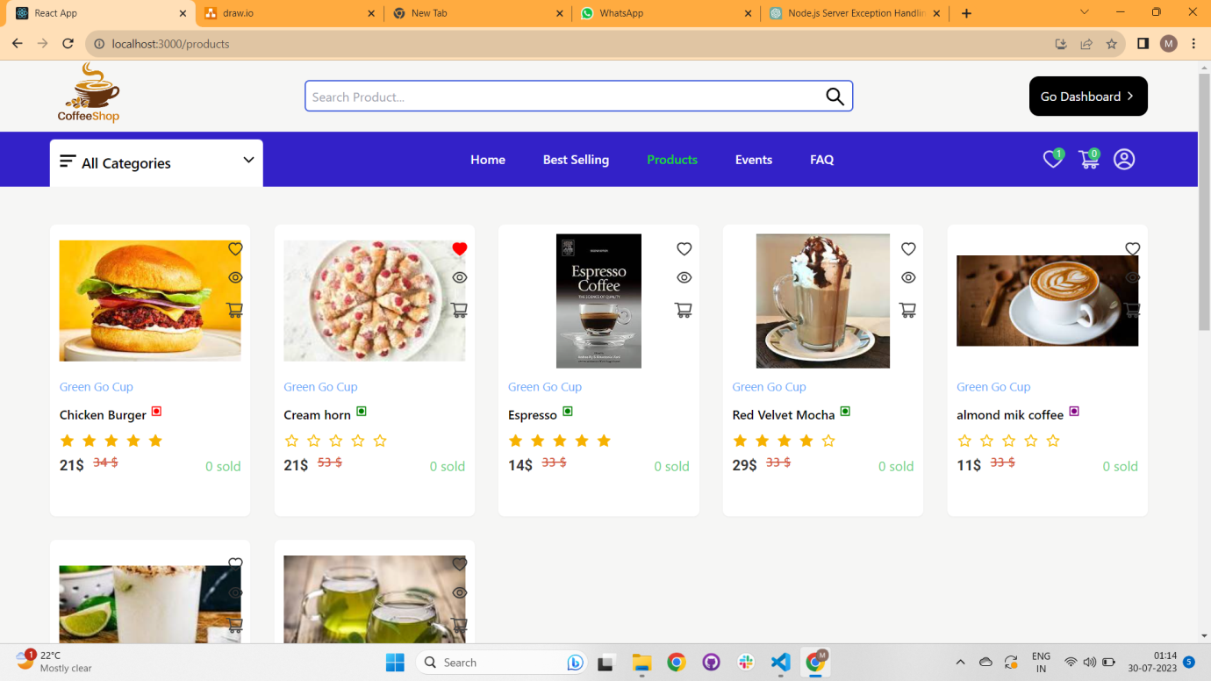

**4. Event Page: /events**

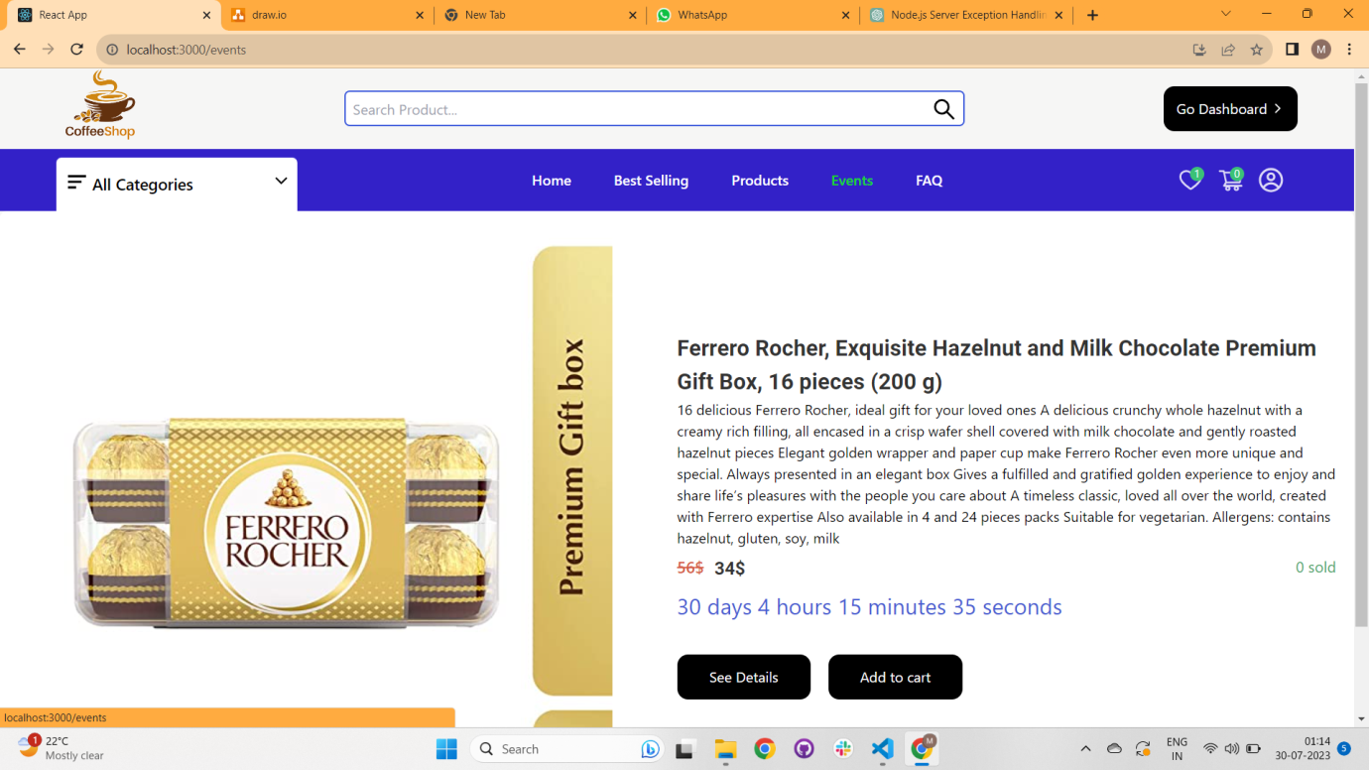

**5. User and Manager signin and signup page:**

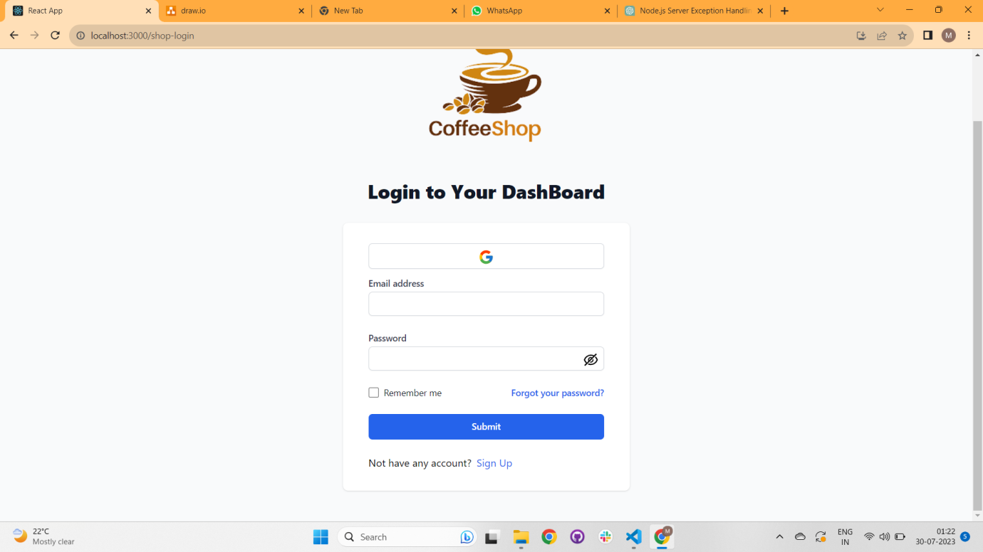

**6. Product Detail Page: /product/:id**

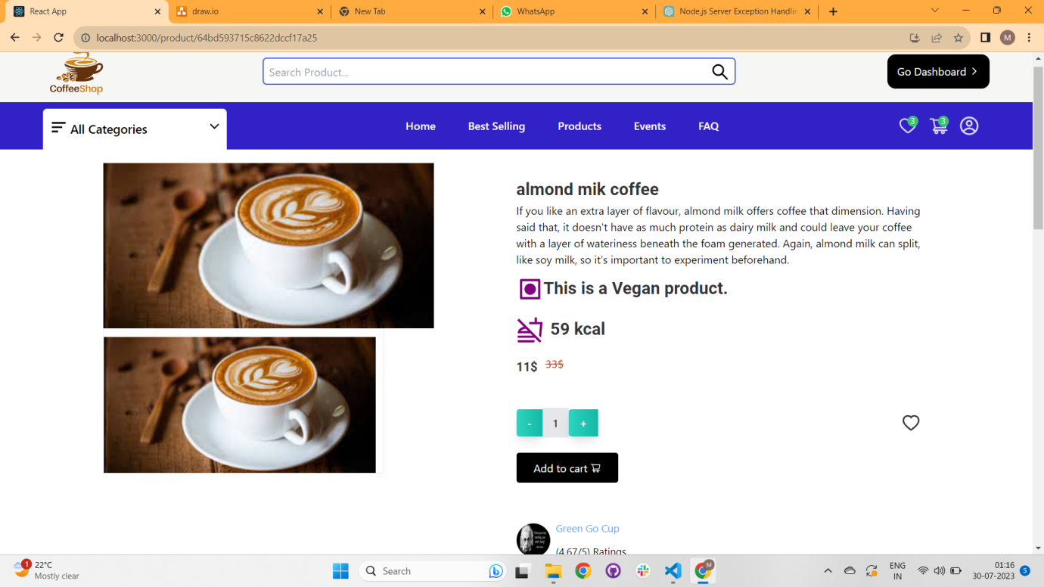

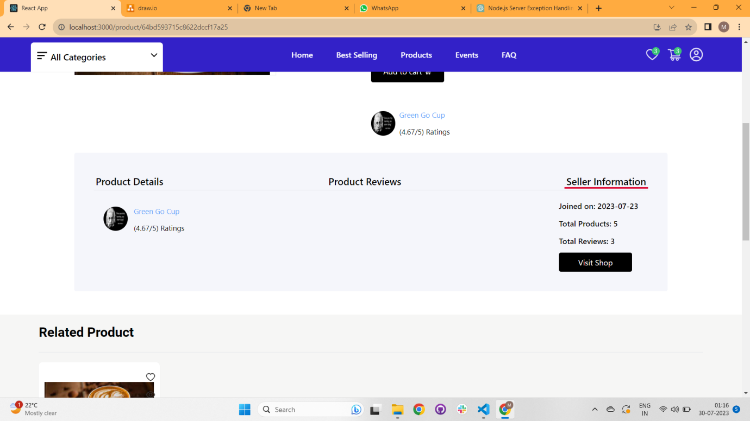

**7. User Profile Page : /profile**

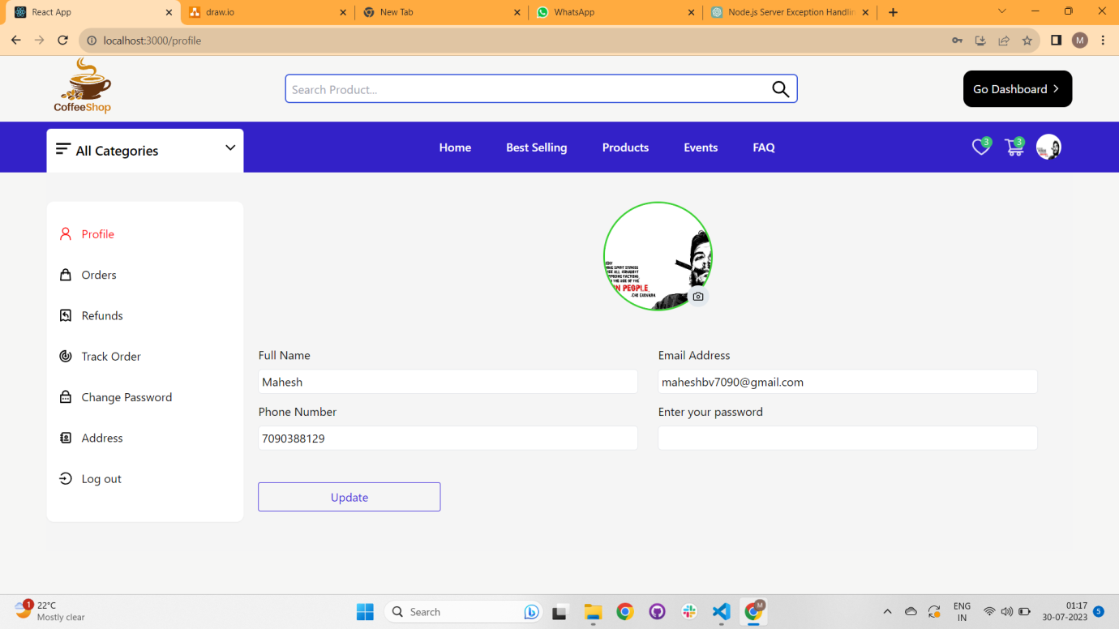

**Total order: where we can see all orders status.**

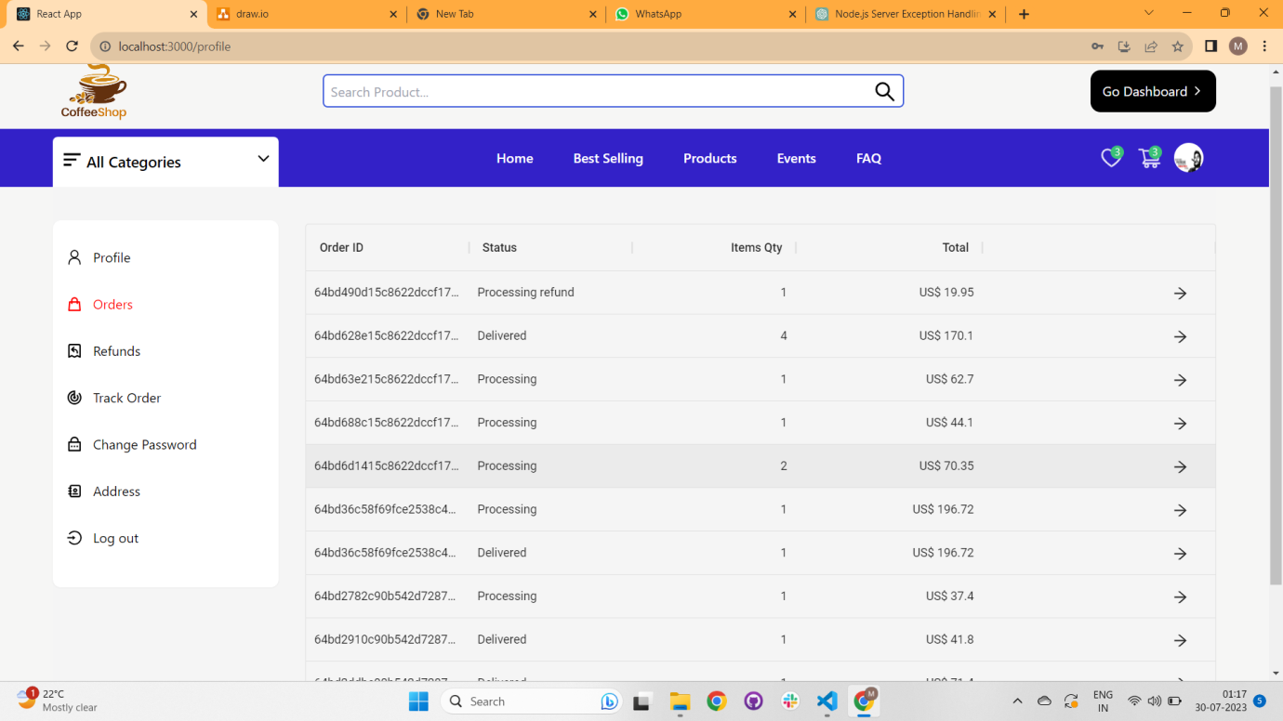

**Order Info and Status and after successful delivered we can review also.**

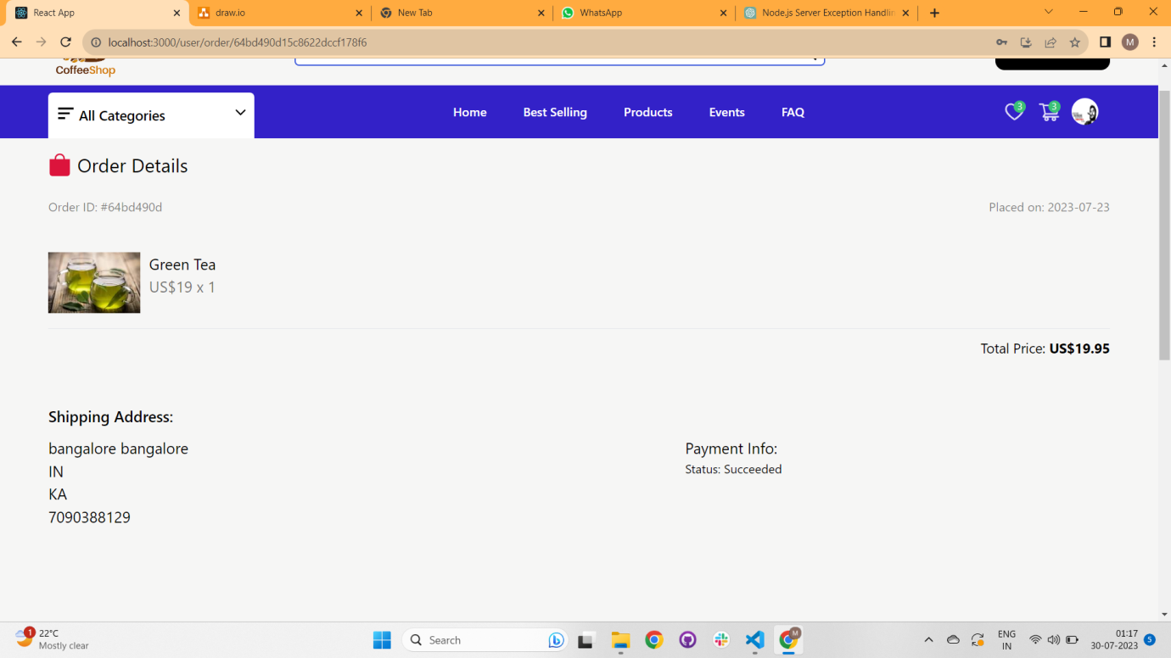

**Add Address :**

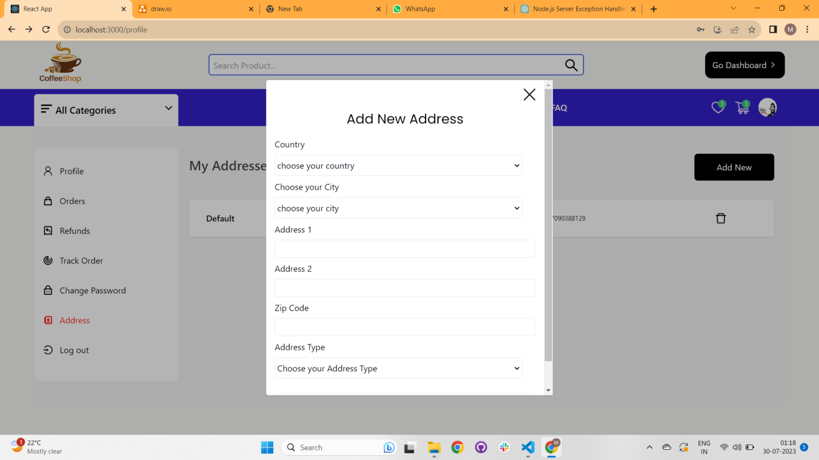

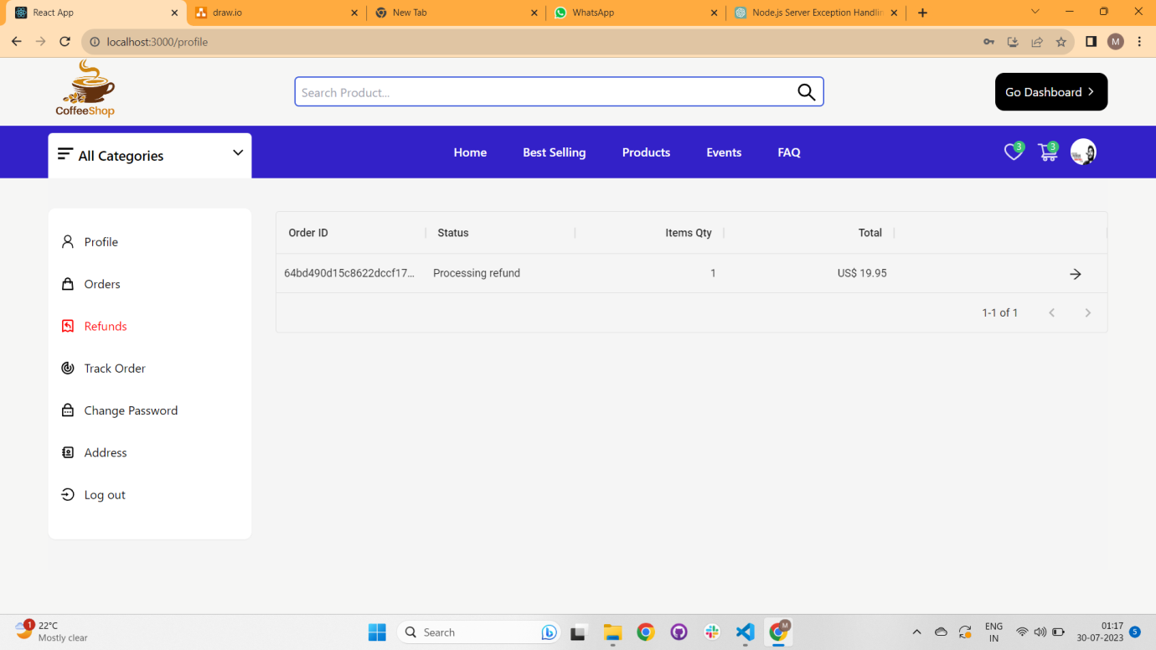

**TrackOrder:**

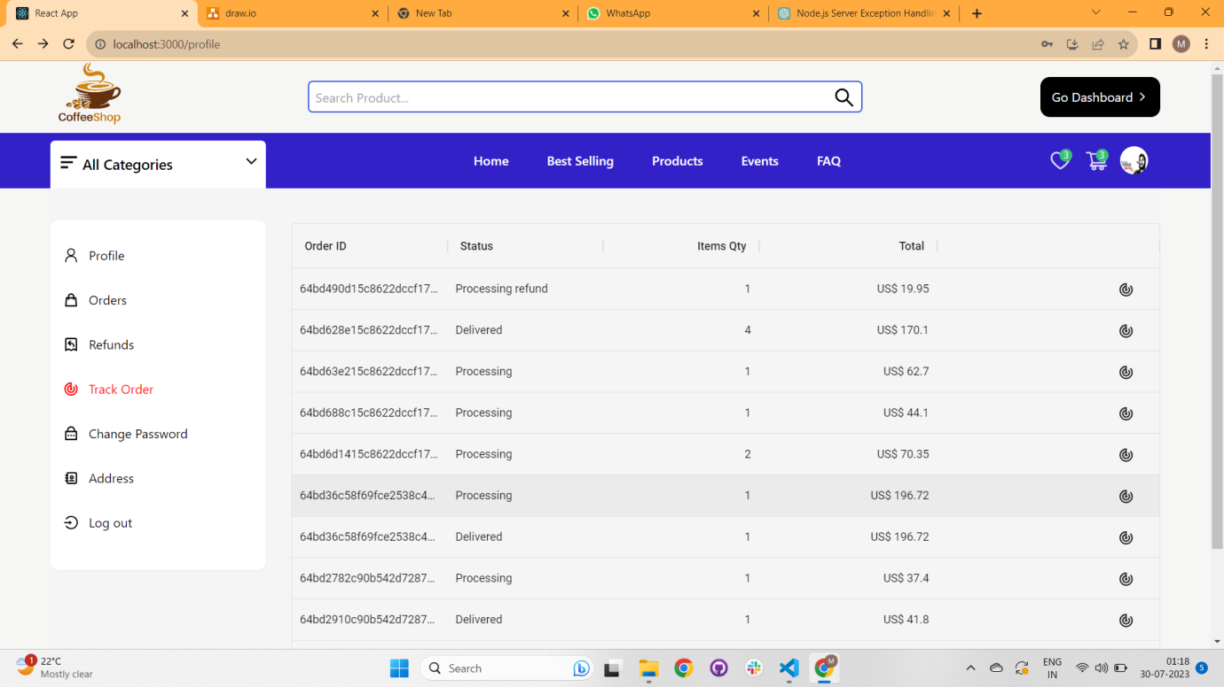

**Change Password:**

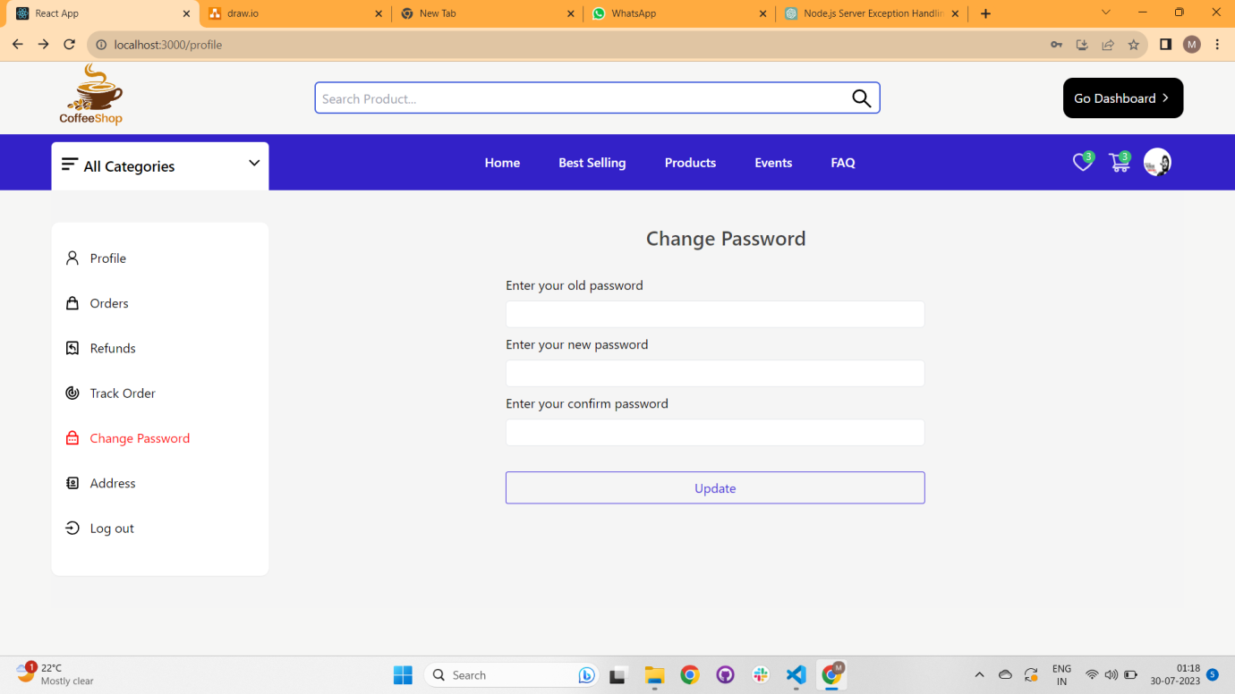

**All Address:**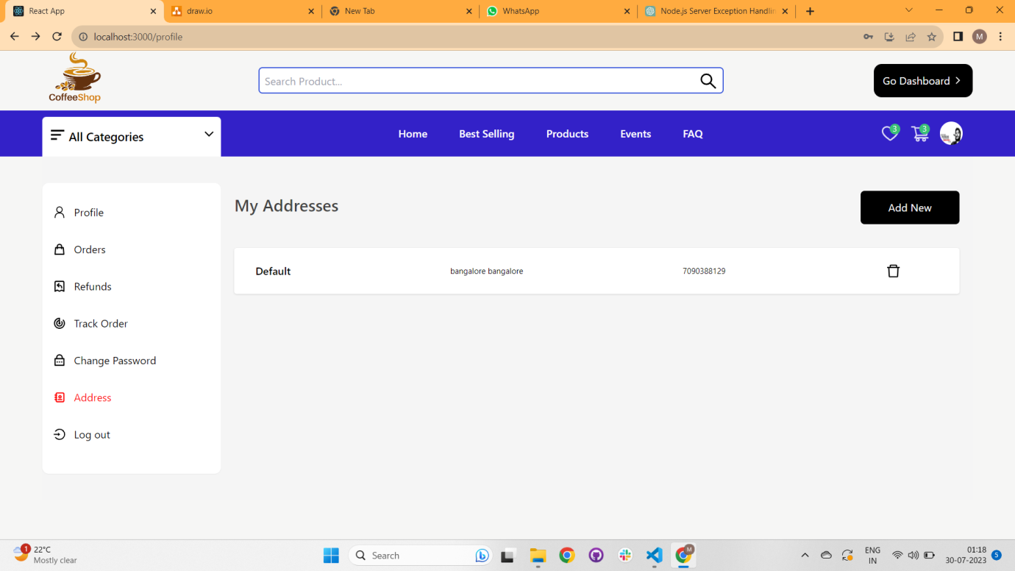

**8. Check out Page:**

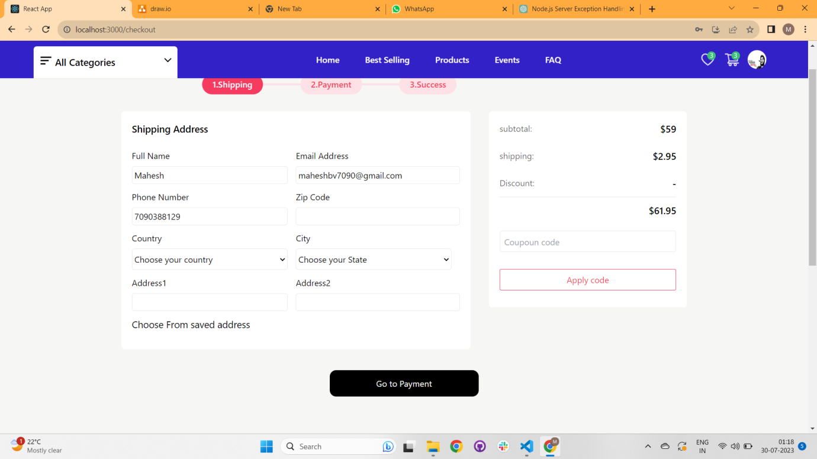

**Can add default address, credit card, paypal, cod and also can add coupon code for discount.**

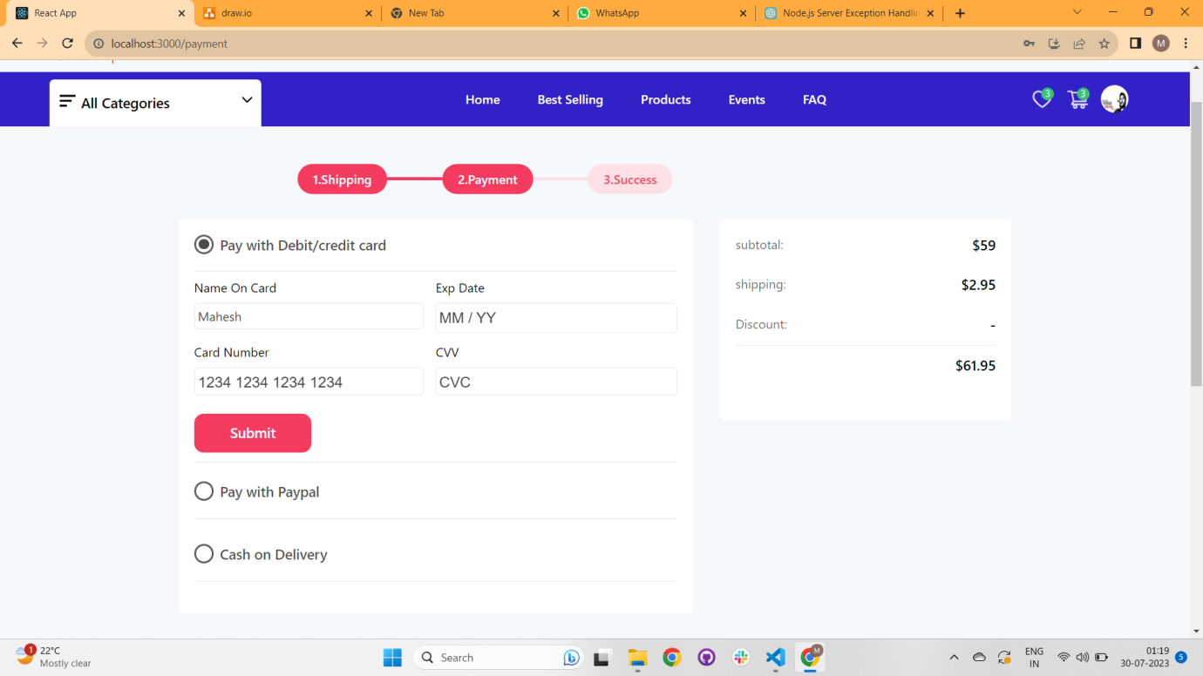

**Dummy Card Number: 4242 4242 4242 4242 , 1234 1234 1234 1234**

**9. Manager and Admin Page: /dashboard**

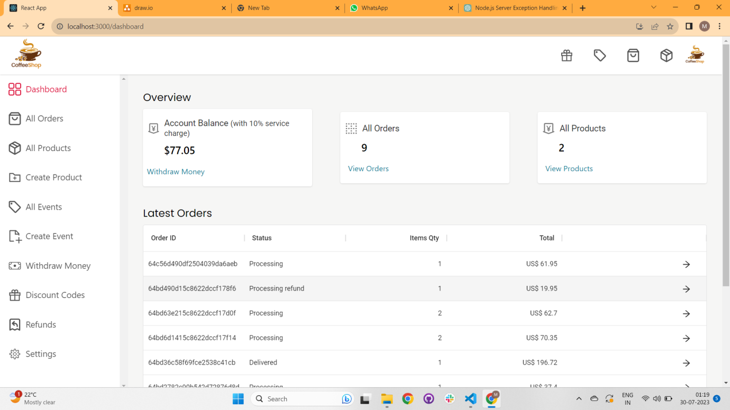

**10.Dashboard Orders: /dashboard-orders**

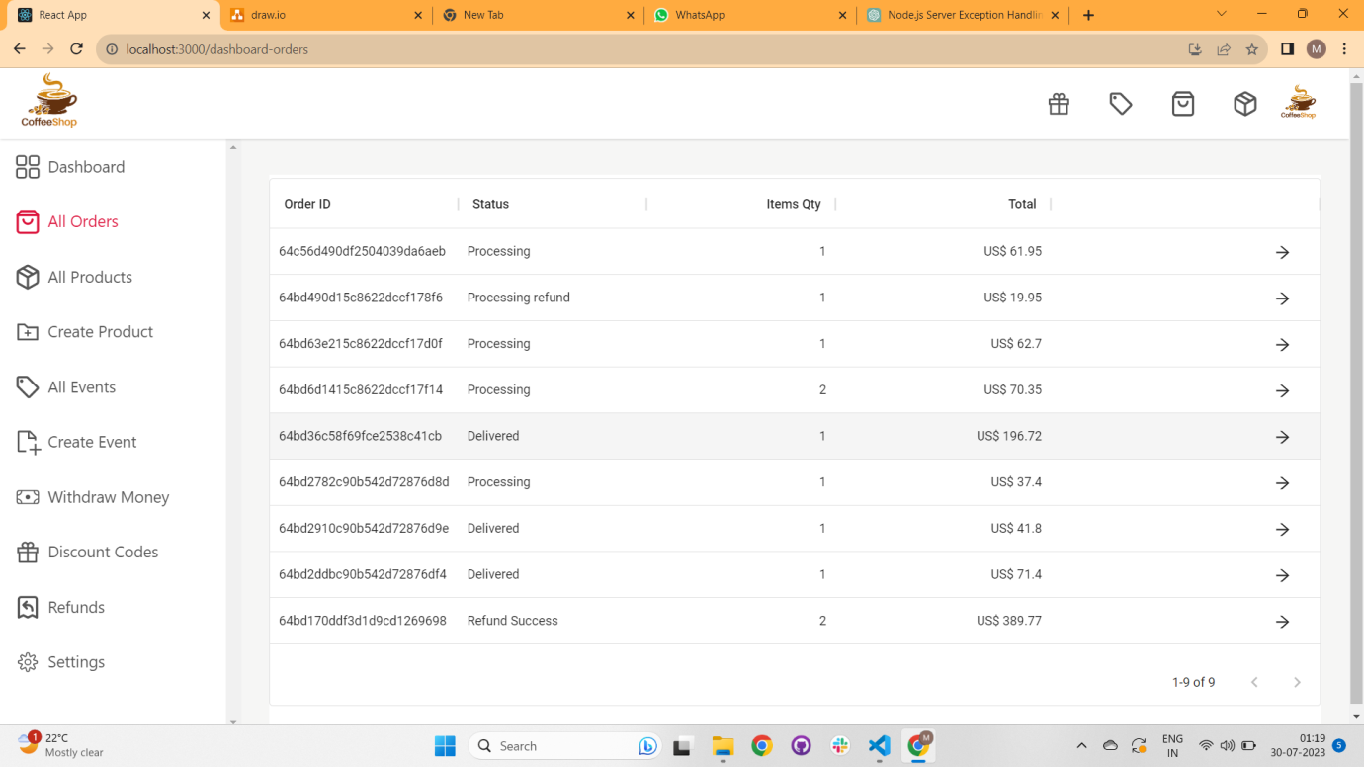

**11. Dashboard Products: /dashboard-products**

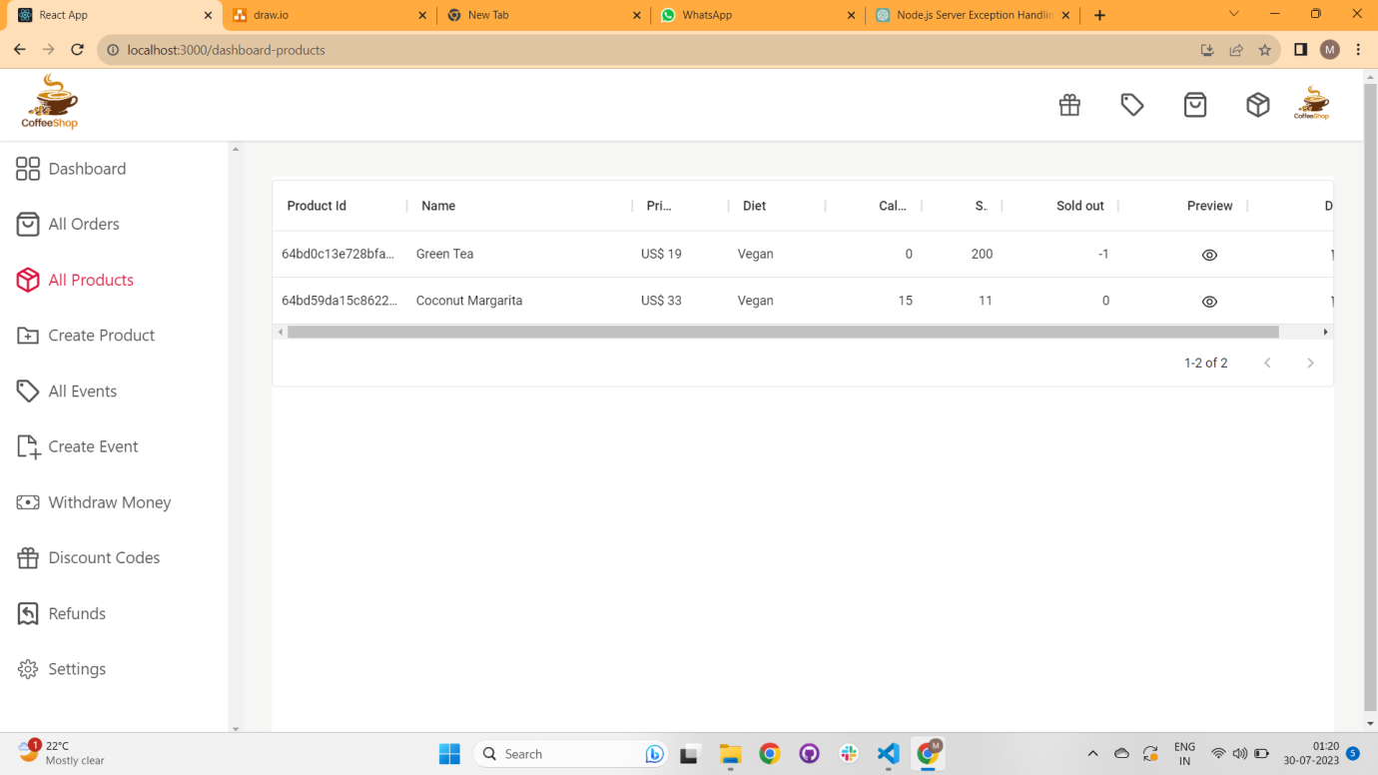

**12. Create Product: /dashboard-create-product**

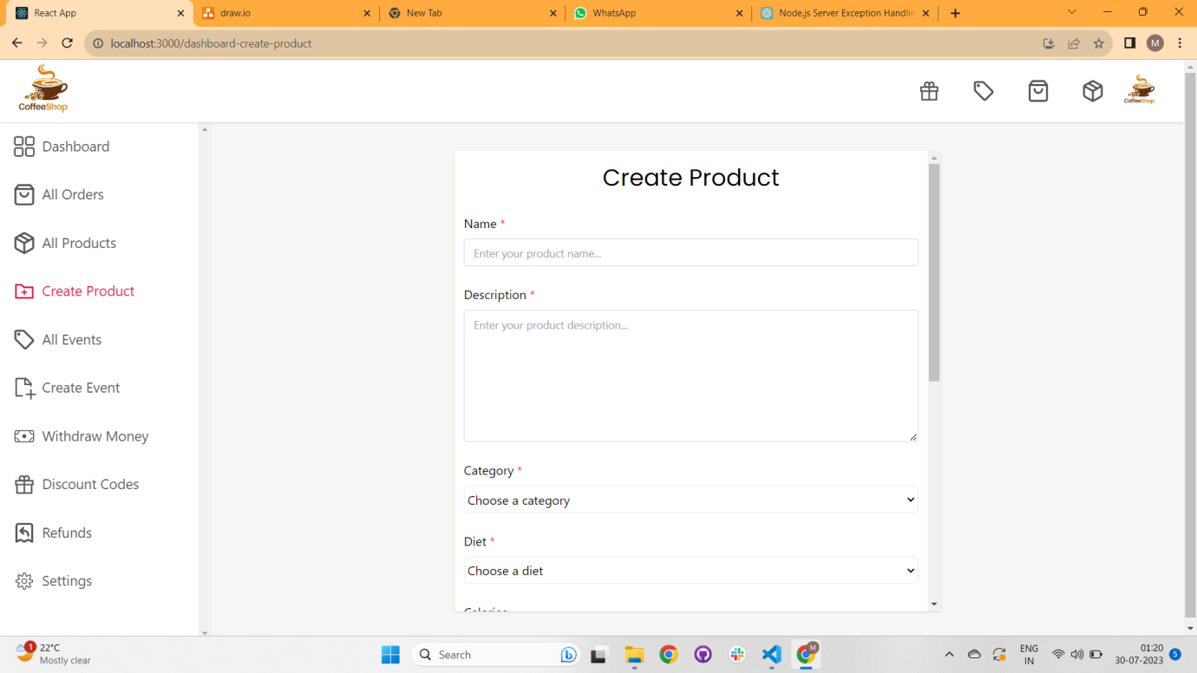

**13. All Events Pages : /dashboard-events**

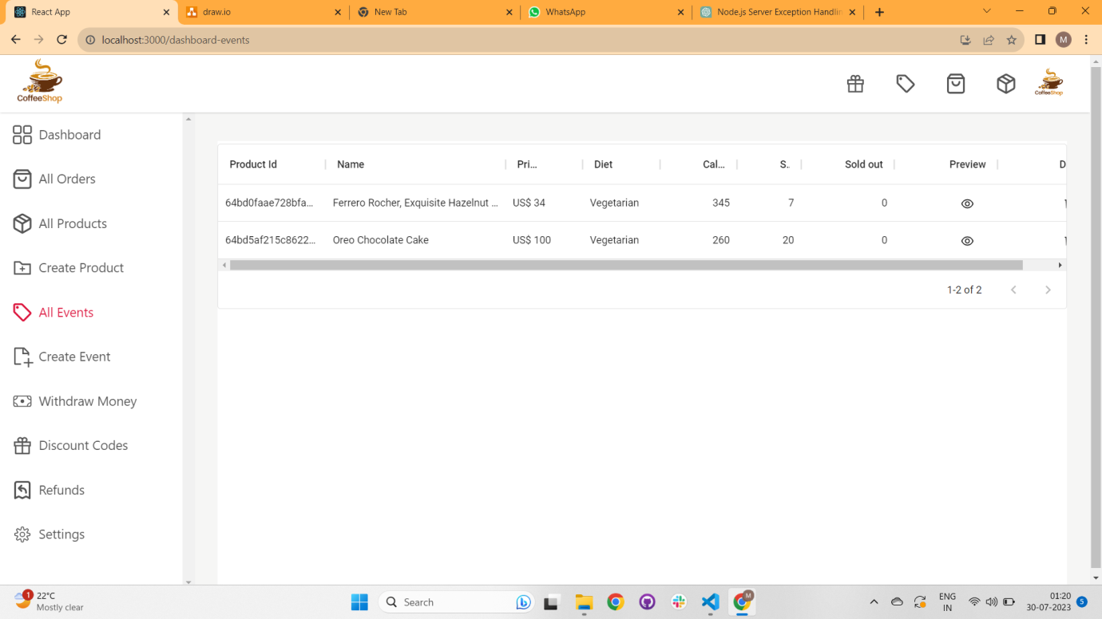

**14. Create Event : /dashboard-create-event**

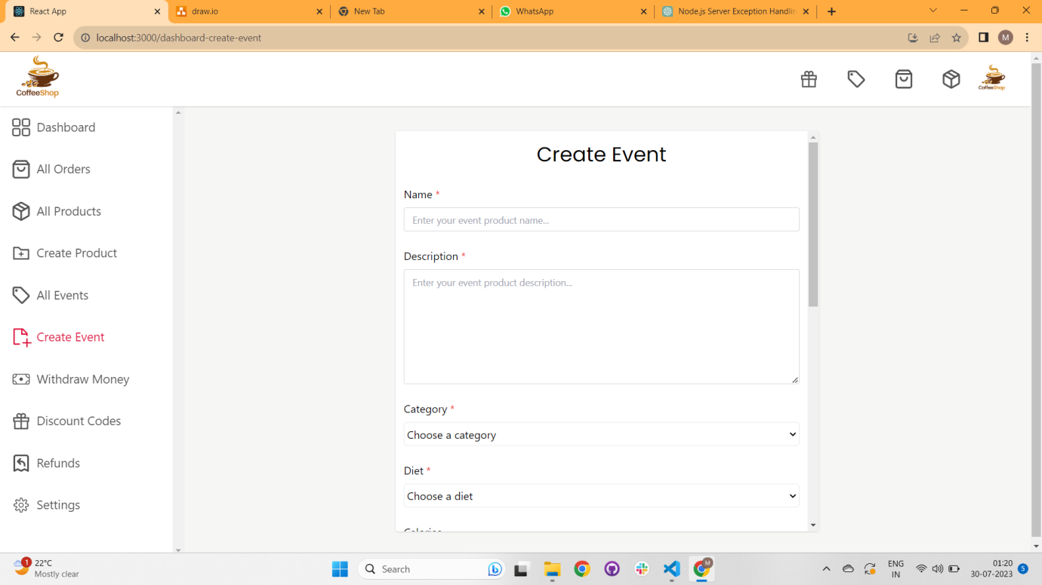

**15. Withdraw Money Page: /dashboard-withdraw-money**

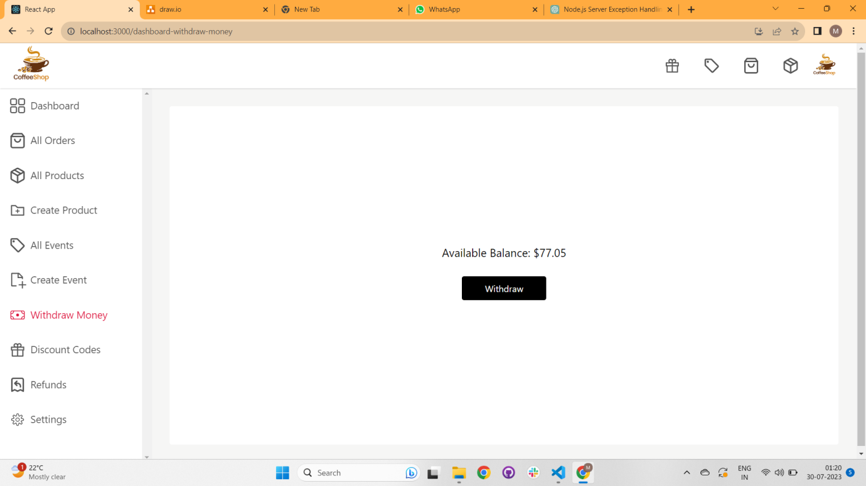

**16. Create Coupon Code : /dashboard-coupons**

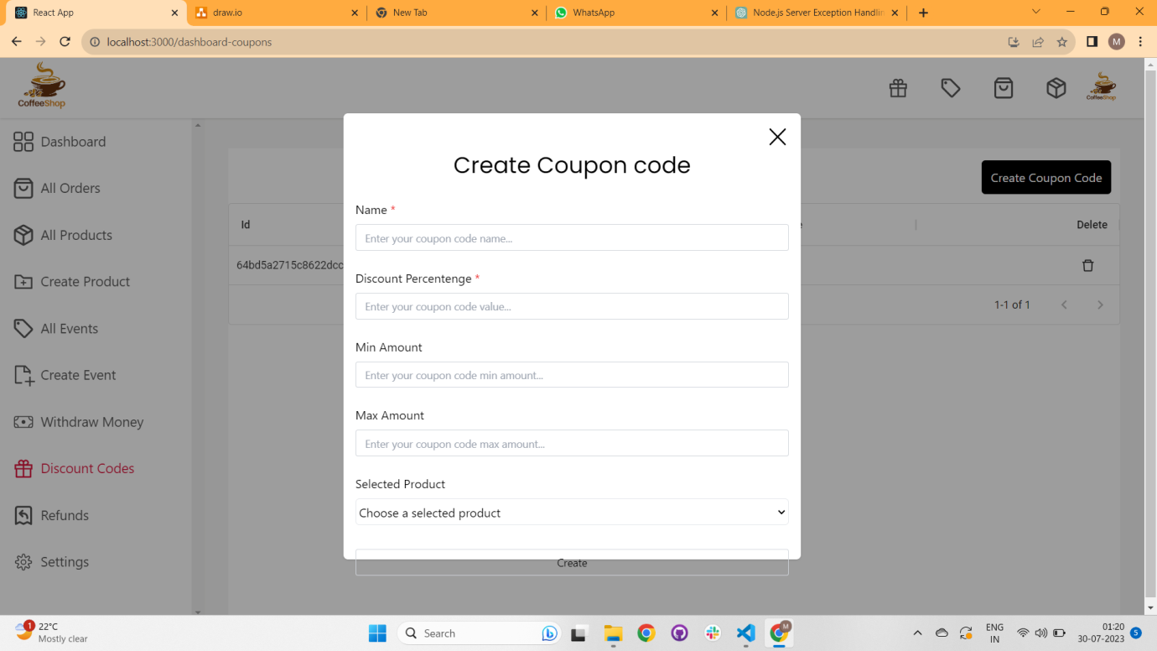

**17. All Refunds: /dashboard-refunds**

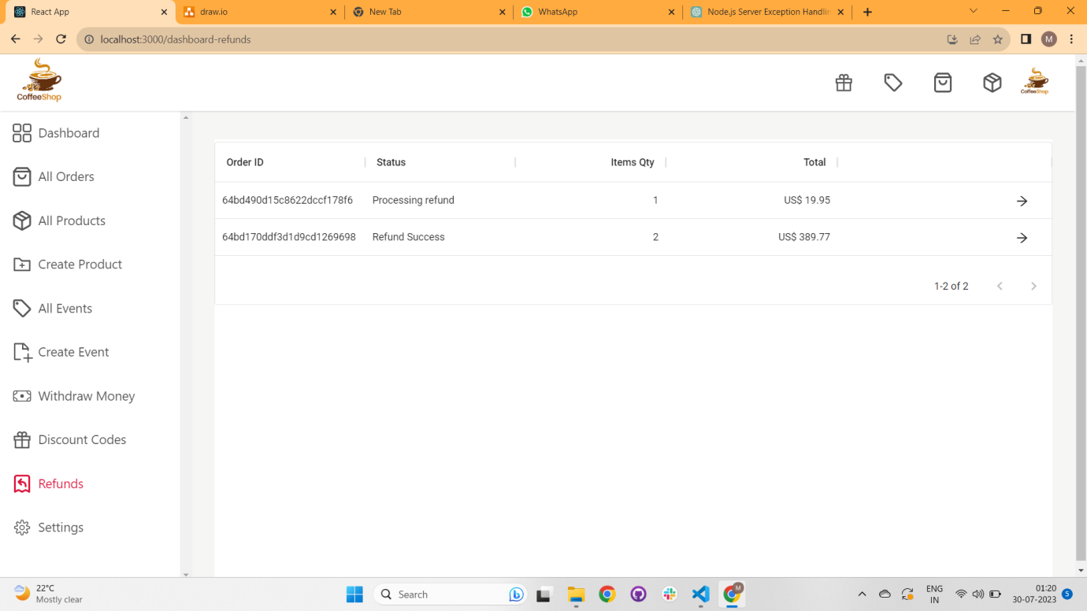

**18. Order Detail Page for Manager: /order:id**

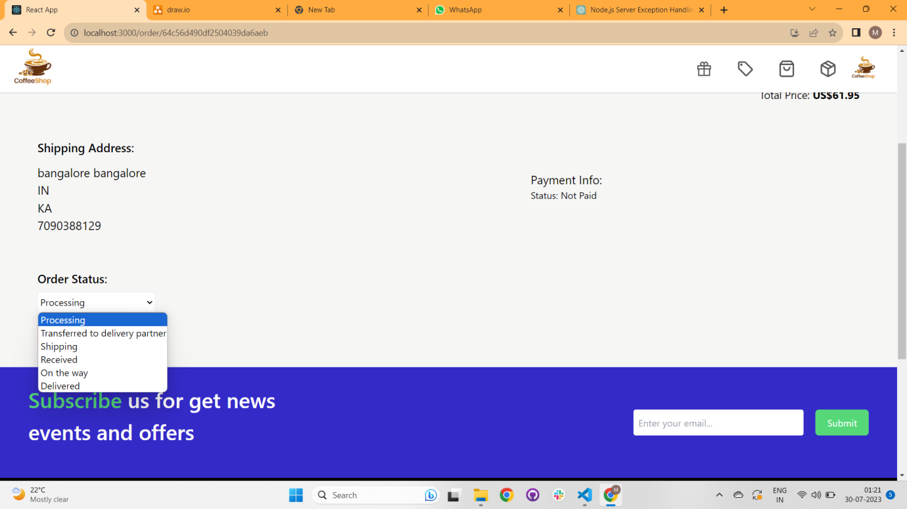

**19. Shop Home Page: /shop:id**

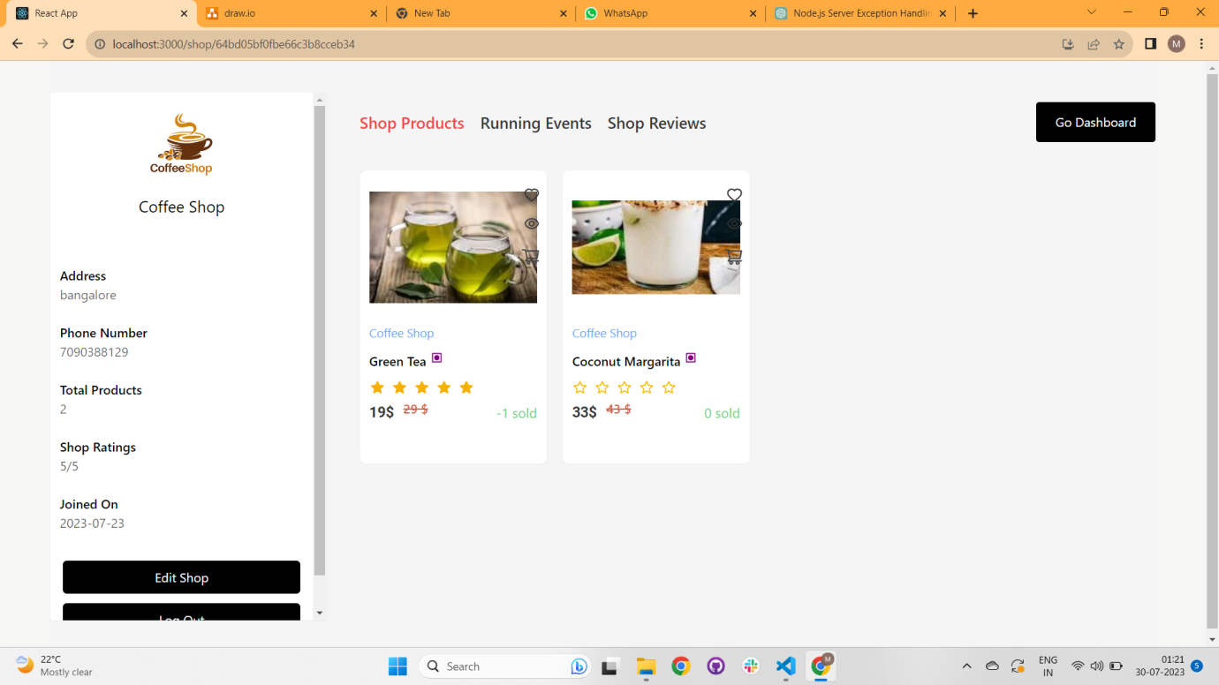

**20. Settings Page : /settings**

